**PROJECT 1:**

Deploying a web server in Windows instance

1. Task 1:Create a windows instance using AMI: Windows 2012 R2 base

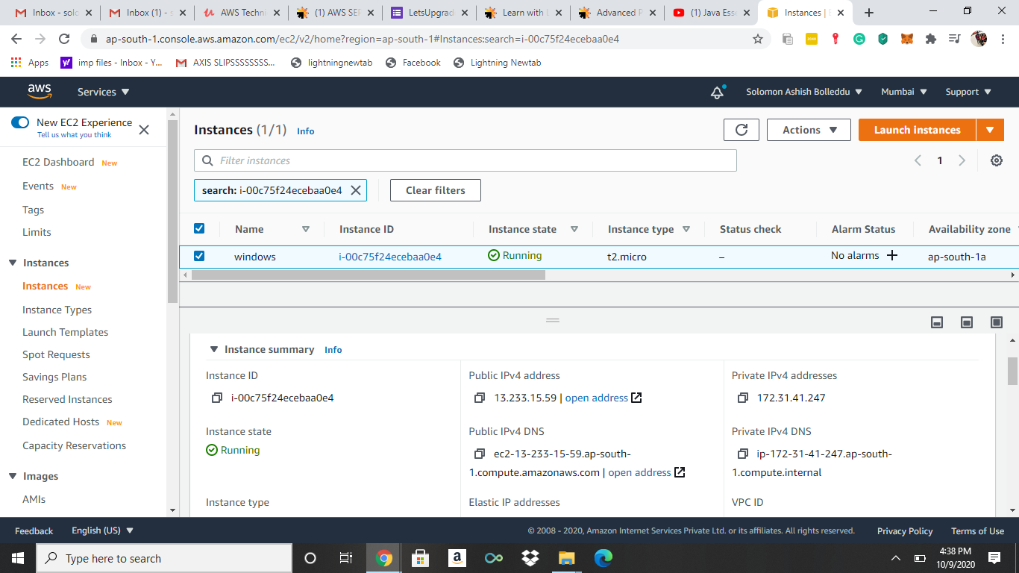

1. Task 2:Launch the Windows instance using RDP

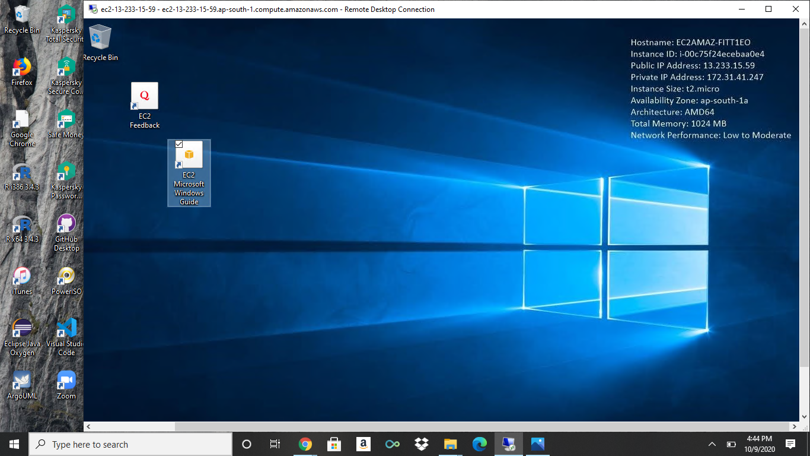

1. Task 3:Install IIS web server using Powershell ISE

Note: Simply copy the command below and paste in the PowerShell ISE to install the IIS web server.

!!!!Powershell is case sensitive.

Install-WindowsFeature -name Web-Server -IncludeManagementTools

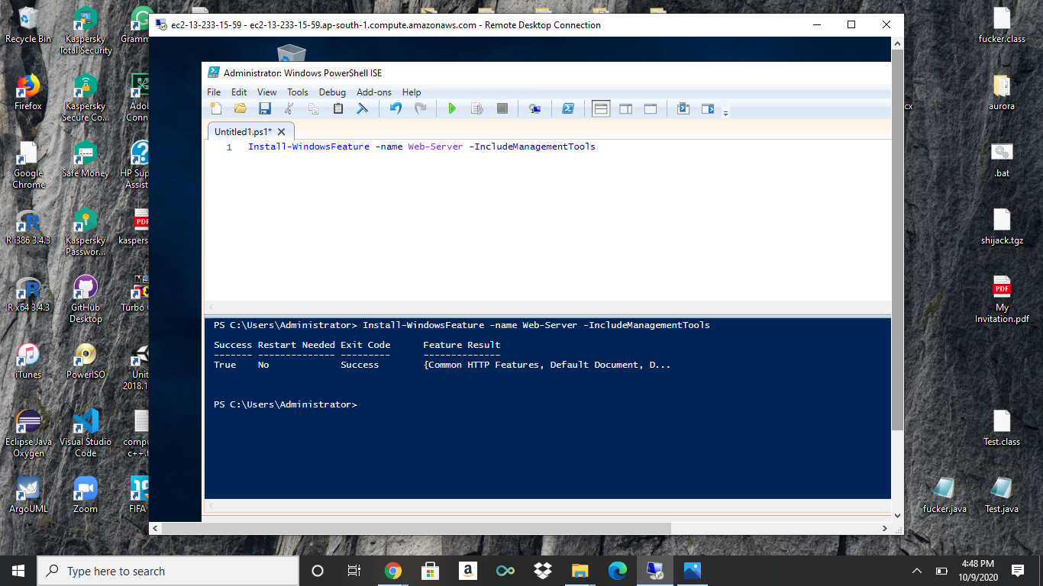

Task 4:Verify successful installation of IIS Web Server

Note: You should be able to see the Internet Information Services Web page when you paste the public IP

into the browser.

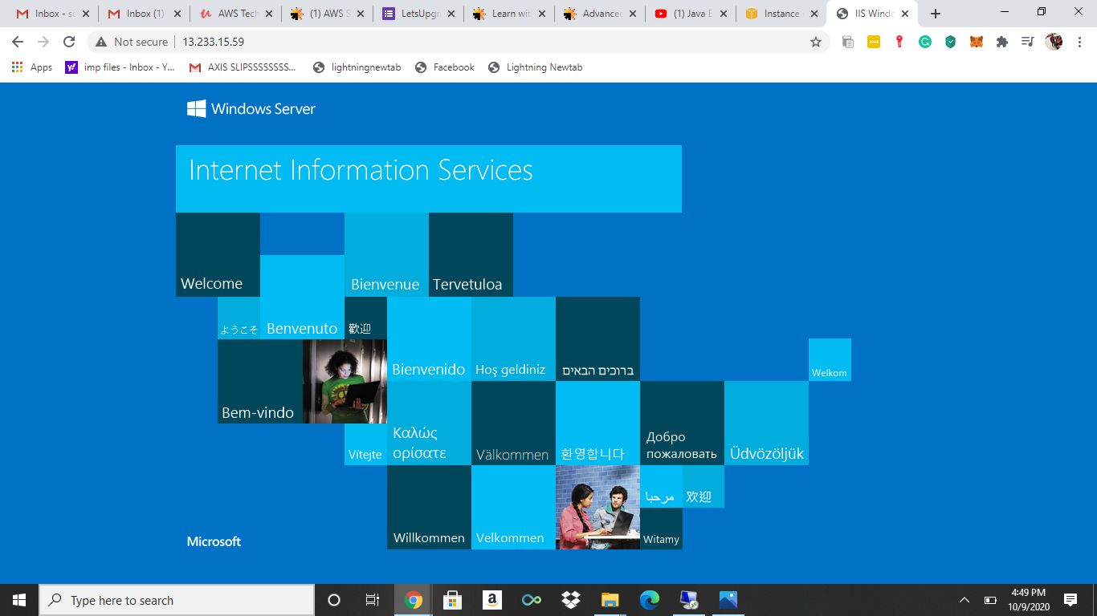

PROJECT 2:

Deploying a web server in Windows instance

Task 1: Create a windows instance using AMI: Ubuntu Server 18.04 LTS (HVM)

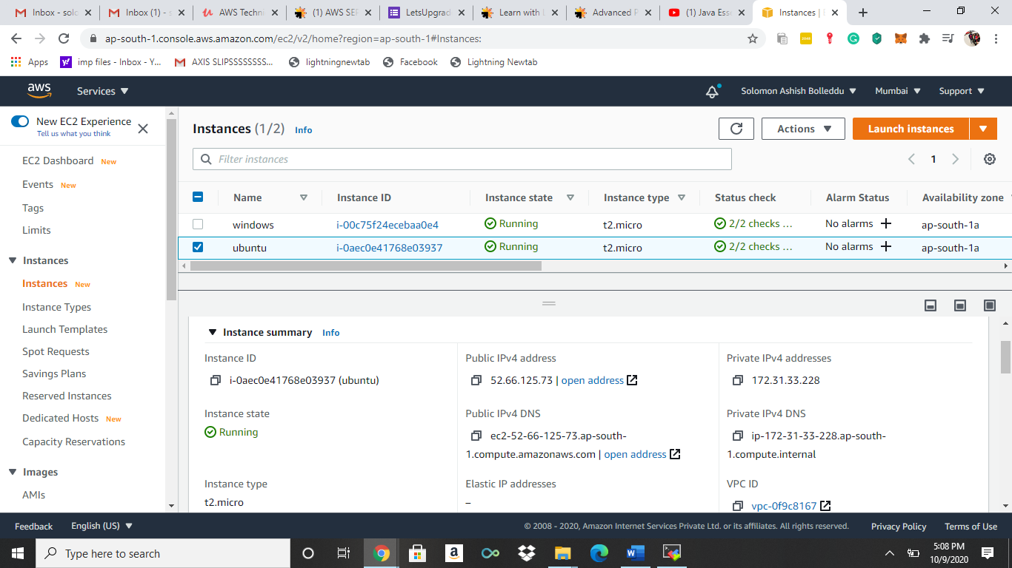

Task 2:Download and install MobaXterm Portable Edition

Task 2:Launch the Ubuntu instance using SSH

Note: Username is ubuntu

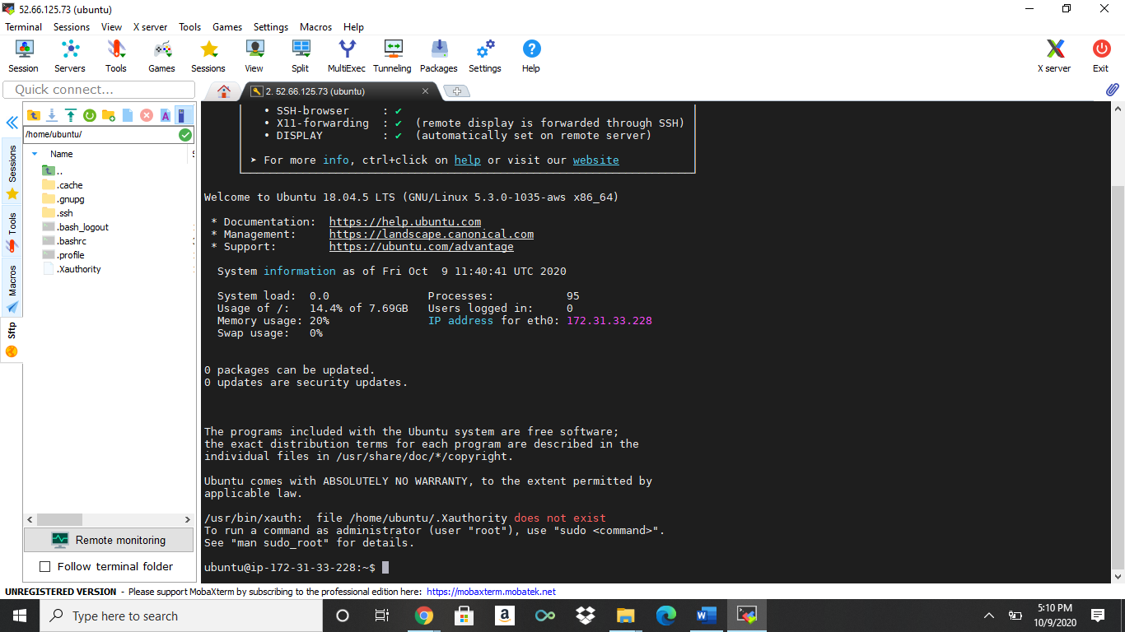

Task 3:Install Nginx web server using bash

Note: Simply copy the command below and paste in the bash to install the Nginx web server.

sudo apt-get -y update

sudo apt-get -y install nginx

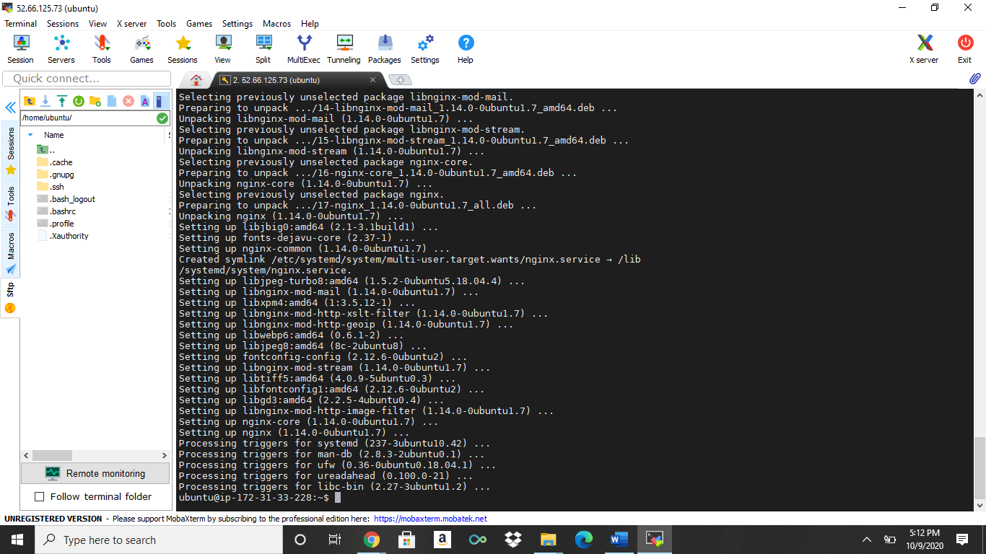

Task 4:Verify successful installation of ngnix

Note: You should be able to see the Welcome to ngnix Web page when you paste the public IP into the

browser.

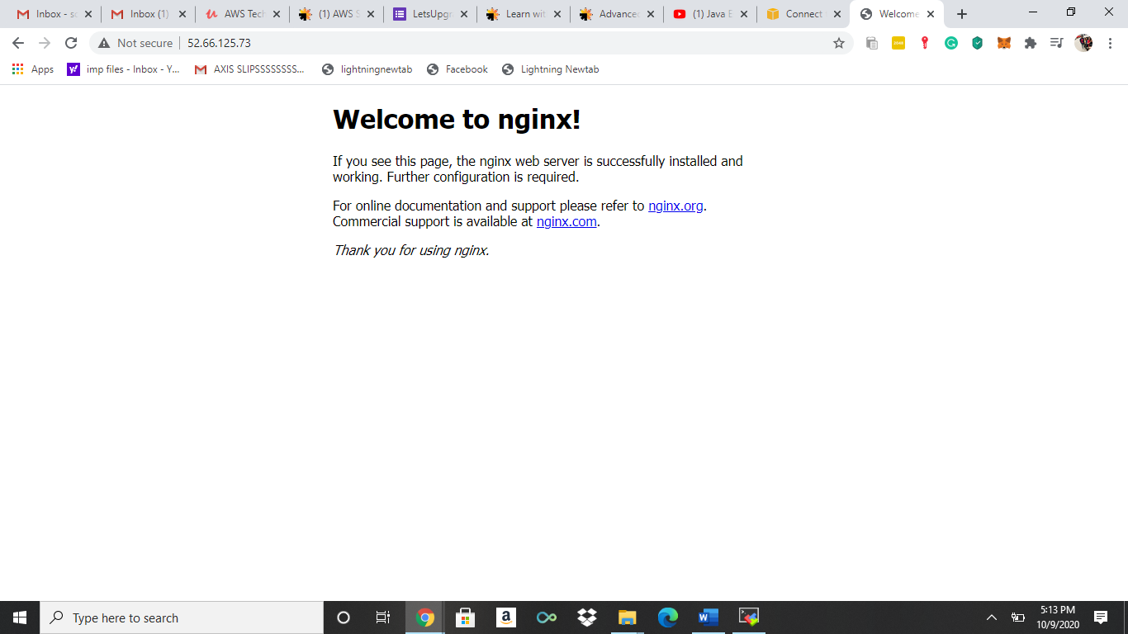

PROJECT 3:

Working with volumes

1:Create a windows machine

2:Create a volume in the same region as the windows machine

3:Attach the volume to the windows machine

4:From server manager bring the volume online

5:Once the ebs is online create a new volume

6:Check if the volume is mounted successfully

7:Try modifying the volume config

8:Delete the volume